**MySETIviewer**

**User’s guide**

**V1.1.1**

**December 27, 2023**

This file is part of MySETIviewer.

MySETIviewer is free software : you can redistribute it and /or modify it under the terms of the GNU General Public License as published by the Free Software Foundation, either version 3 of the License, or (at your option) any later version.

MySETIapp is distributed in the hope that it will be useful, but WITHOUT ANY WARRANTY; without even the implied warranty of MERCHANTABILITY or FITNESS FOR A PARTICULAR PURPOSE. See the GNU General Public License for more details. You should have received a copy of the GNU General Public License along with MySETIapp. If not, see

<https://www.gnu.org/licenses/>.

MySETIviewer is an application that was written to help visualize the bit stream message from the ‘A Sign in Space’ project. This is a user driven effort and has no official affiliation with Daniela de Paulis, the SETI Institute, or the European Space Agency or any other collaborating agency or institute.

**Background**

'A Sign in Space'

website, <https://asignin.space/>

A Sign in Space is an interdisciplinary project by media artist Daniela de Paulis, in collaboration with the SETI Institute, the European Space Agency, the Green Bank Observatory and INAF, the Italian National Institute for Astrophysics. The project consists in transmitting a simulated extraterrestrial message as part of a live performance, using an ESA spacecraft as celestial source. The objective of the project is to involve the world - wide Search for Extraterrestrial Intelligence community, professionals from different fields and the broader public in the reception, decoding and interpretation of the message. This process will require global cooperation, bridging a conversation around the topics of SETI, space research and society, across multiple cultures and fields of expertise, <https://www.seti.org/event/sign-space>

The message was transmitted from the ESA's ExoMars Trace Gas Orbiter (TGO) on May 24 at 19:16 UTC/12:15 pm PDT.

It was received by three radio telescopes on earth May 24,2023. A group of individuals in the Discord 'A Sign in Space' channel unscrambled the message from the radio telemetry. The message published as Data17.bin is identified as the correctly transcribed bitstream of the message payload given to ESA.

The next step in the problem is the decoding of the payload bitstream into the next level of the message, the sign in space. After that the interpretation of the sign(s) in the embedded messages can commence.

There is a Discord Interpretation Chat. The group is large and has a wide array of talent. The tools that the group is using is quite varied which includes Excel, Photoshop, GIMP, Java, Python and c/c++.

Several people are also using online tools that use file uploads, typically text based. Importing data into Excel is also generally text based.

Photoshop and GIMP can use raw binary files typically 8 bit, 16 bit or 32 bit per element.

None of these tools use bit packed binary input. The first step has been to translate the bitstream message into a format that can be used by the various tools. The next steps involve examination of the bitstream data to solve how to decode it.

**About MySETIviewer**

This program is a viewer that I am using in the examination of the message. It allows the user to create layers from images of the bitstream, overlay the layers, change the alignment of the layers relative to each other, assign colors to a layer, and a ruler with major and minor grids Hopefully this may make it easier for others people to explore the message.

**Limitations**

This is a 64 bit Windows Desktop application. It uses .raw and .bmp files for the layers. It also has some functions to convert space delimited text files to .bin files along with conversion of .bin files to .raw image files. PNG files can not used as input for a layer. The PNG file type typically has too much data loss to accurately import.

**Release Notes**

**V1.0.0 Release**

This is the first release. It includes the Visual Studio project files along with some of the A Sign in Space data files. An application installer can also be used just for the executable application and data files.

**V1.0.1 Release**

Fixed bug in generating PNG files. No changes to the user interface.

**V1.0.2 Release**

Added y position direction flag. This allows the user to specify which direction on the screen a change in change moves a layer in the Image window.

**V1.1.0 Release**

Change, the Layers dialog changed so that it can remain open while accessing the menus.

Change, Menus, Layer heading changed to File heading

Change, Menus, New, Add Layer, Remove Layer, Reload all layers moved into the Layers dialog

Added, Global to allow the Display and Layers dialogs to stay open when pressing OK or Cancel

**V1.1.1 Release**

Added, Status bar to image window

Changed, zoom ,pan behavior of the image window

Changed, window resize of the image window

Correction, fixed bug when min. overlay size was not square

Added, reset window positions upon next restart

Changed, zoom range, now 0.5x to 20x

**Installation**

**Any installer and/or executable should be scanned for viruses when being downloaded. A verification that the checksum for the installation matches the download can also be done as an additional precaution.**

The installer will add a desktop shortcut to run the application along with a Window Start menu entry named MySETIviewer

The installer is a very simple one. **The default install location is the windows volume drive \MySETIviewer. This typically c:\MySETIviewer.**  This is used because the application needs to be able to have read/write access of the folder it is installed. The ‘Programs folder’ requires administrative privileges to write to it. I use ‘C:\MySETIapp’ as the installation location. You can change the folder installation of the application using the browse button during the install.

The project source is also available on GitHub. The source code, project, and solution use Visual Studio 2019 or later. It has not been tested against earlier versions.

file, MySETIviewer.ini, that will be created when you run the software that keeps track of what files, parameters, window size and positions are used so that you do not have to start from scratch every time you run the application. This is stored in the same folder as the executable. The application does not need to access, record, or transmit information to the Internet.

**LAYERS and DISPLAY**

There are 2 basic part of the viewer; the Layers, and the Display (Image window).

A layer is an image loaded from a .BMP or .RAW file. A layer is treated as a binary image. If a pixel is 0 then it is assigned the Layer background color. If it is not 0 then it is assigned the Layer color. Up to 8 layers can be added to the overlay. This viewer works by creating an overlay of the layers. Each layer can be moved within the overlay. This allows the layer alignment to be set for each layer. The overlay image without the rulers can be also saved as a .BMP file. The layers are controlled from the Settings->Layers dialog.

The Display takes the overlay image and applies the ruler as defined in the Display Settings dialog. The Display is shown as a separate Image window which can be resized, panned, and zoomed. The overlay image with the rulers can be saved as a .BMP file.

**First time running the application**

A temporary working directory needs to be specified. This should be the first thing done when you run the application. Go to Settings->Global in the menus. Browse to the folder to be used as the Temp folder. I use c:\MySETIviewer\Temp which is created by when the program is installed.

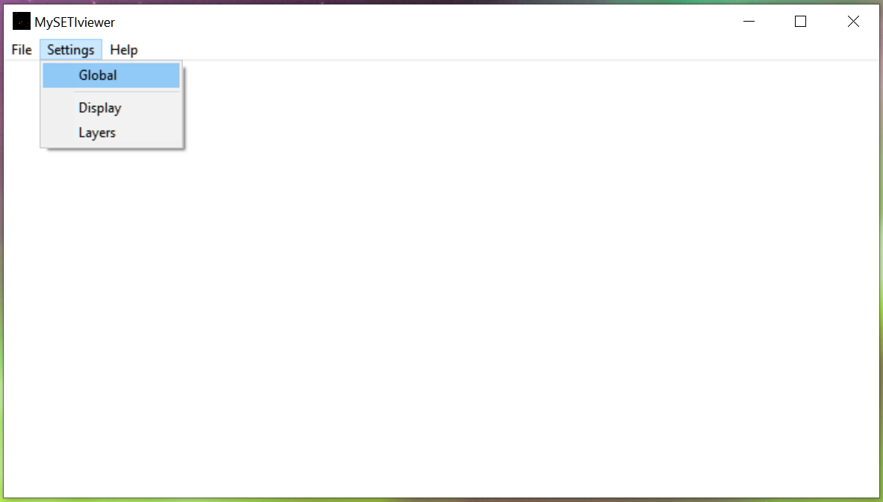

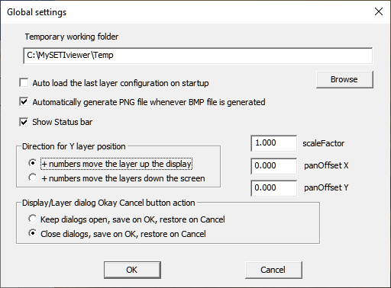

The next step is to resize the application window. The size and position of the application on the screen when the application exits will be used the next time the application runs. You only need the application to be large enough to see and use the menus. No data is displayed in the main application screen. Go ahead exit and restart the application.

**Display**

When you reopen the application again it will also show the Layers and Display dialogs. You should move the dialogs around so you can see the dialogs and the app windows at the same time.

The dialog will remember their screen position for the next time it.

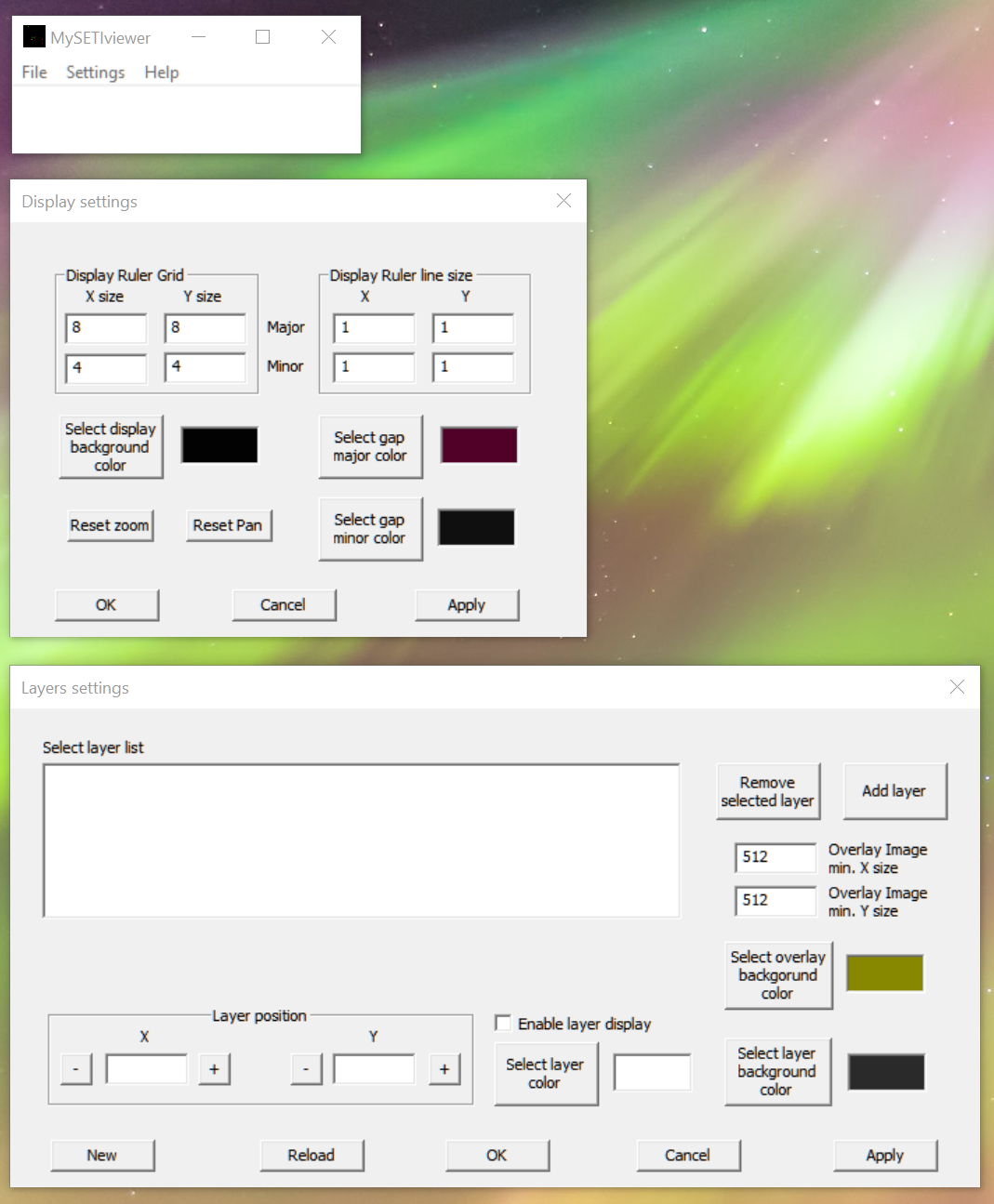

I would recommend using the default colors initially. In case you change them and want ot change them back, theDisplay settings are; background RGB = 2,2,2, Major Gap RGB = 81,0,40, and Minor Gap RGB = 30,30,30 and the Layer settings are: Overlay background RGB = 136,136,0, Layer background RGB = 1,1,1, and Layer RGB = 255,255,255.

If you accidentally close the Display or Layer dialog you can always open it again from the menus; Setting->Display. The default option in the Globals settings is to keep them open when you click OK or Cancel. OK saves the settins and Cancel restore the previous settings.

The next step is to add some layers. We will start by just adding 2 layers. Press the ‘Add layer’ button

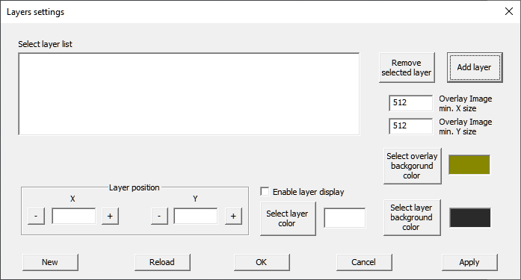

Go to the c:\MySETIviewer\Data directory and select the ‘Message 256x256.raw’.

Do this a second time using the same ‘Message 256x256.raw’.

The Layers settings dialog should look like the following:

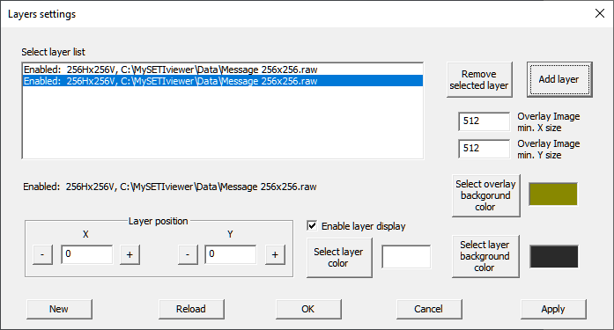

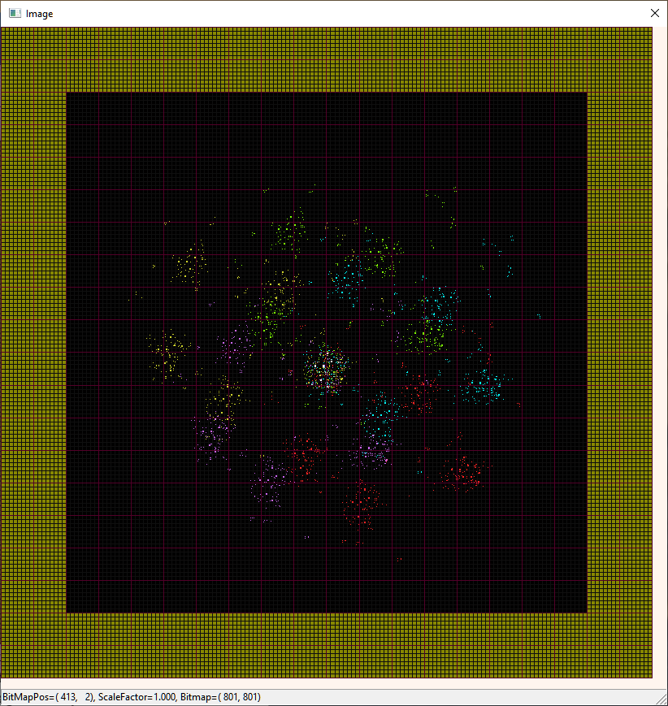

Each time an image is added will cause the Image window to appear. The Image window should look like this. If it does not, try resizing the window. The overlay image where there is no image is dull yellow

Try changing the selected Layer position in both x and y. Try changing the color using the Select layer color button to see the effect. The initial colors for layers when the program is first run is white.

After moving the layers around try enabling and disabling a layer to see the effect.

From the application menu select Layer->Save Layer Configuration and save it. This allows you to quickly load different layer configurations you are trying.

If you prefer to be able to close the Display and Layers dialogs change the setting in Settings-> Global.

Try loading the ‘5 sign 0 padded.cfg’ configuration file. HAVE FUN.

**If you do not see the Image window, click the Apply button.**

**Menus**

The menus are simple. There are only 3 headings:

File Settings Help

**File menu**

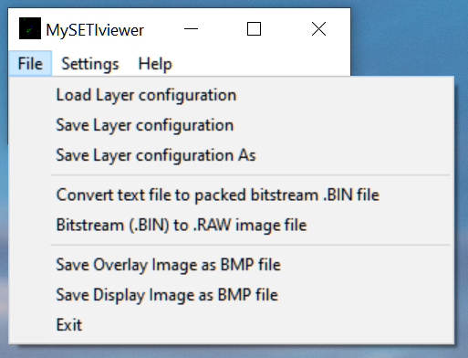

The Layer menu has of the overhead operations involved with loading configuration, saving configurations, converting image files of different types and saving results.

**Load Layer configuration**

This loads a layer configuration file. It removes all currently loaded layers first. All colors definitions including display and display rulers are reloaded as part of the layer configuration file.

**Save Layer configuration**

This saves the current configuration. If the configuration was loaded from a file, it is saved back to that file.

**Save Layer configuration As**

This saves the current configuration as a new file.

**Convert text file to packed bitstream .BIN file**

Many online users have been using text based files or generating text based files.

This operation imports a binary input text based input file with whitespace delimiters. Values >0 are set to 1. The input is packed into bytes. If not enough bits are in the input file to complete the last byte, then that byte is 0 padded to complete it.

**Bitstream (.BIN) to .RAW image file**

This viewer application uses .raw or .bmp files as input. The ‘A Sign in Space’ message is a packed bitstream .bin file. This operation can convert the message into a .raw file that can be used by this application.

**Save Overlay Image as BMP file**

This saves the current Overlay image being displayed as a 24 bit BMP file. This does not include the ruler. Use the ‘Save Display Image as BMP file’ if you wan to include the ruler in the image.

**Save Display Image as BMP file**

This saves the current Image window being displayed including the ruler as a 24 bit BMP file. If you do not want to include the ruler, then use the ‘Save Overlay as BMP file’.

**Exit**

This exits the program. You DOES NOT automatically save your current configuration. You should save your current configuration if you want to save it before exiting.

**Settings menu**

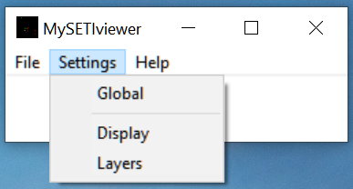

The Settings menu allows the user to set the global parameters, Display parameters and Layers parameters.

**Global**



There are only a few global settings. The temporary working folder must be defined when the application is initially started.

The ‘Direction for Y layer position’ selection determines the direction a layer moves when the position is changed. It is far more natural for most people to consider a positive number to moves up the screen (higher in elevation).The default is for positive number to move up the screen. Changing this setting will automatically change the Y position values to reflect the change.

The Keep dialogs open settings allows the user to decide what happens when you click OK or Cancel. Many users are used to the OK saving the settings and closing the dialog and Cancel not saving the settings and closing the dialog. This settings do not affect the saving and restoration of settings. It only affects whether the dialog will close or not. If you choose to close the Display or Layers dialogs. You can reopen those dialogs under the Settings menu.

Show status bar makes the status bar in the image windows visible at the bottom of the image window.

Scalefactor, PanOffsetX and PanOffsetY allows the user to optionally set those parameter to specific values. The user normally would not use these fields.

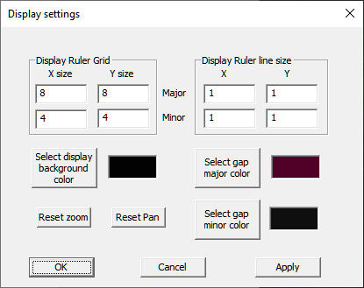

This dialog sets all the display parameters that control the rulers for the display. The x,y ruler grid sizes must be greater than or equal to 1. The minor ruler size is in image pixels. The major ruler size is the number of minor ruler divisions per major ruler division. If you do not want to use major or a minor ruler then set the line size for that ruler to 0.

The displayed image can be panned and/or zoomed. The Reset buttons allow the pan and zoom of the displayed image to be quickly reset.

**Layers**

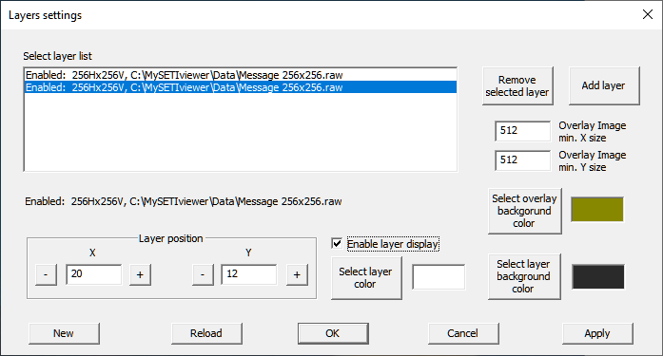

This allows full control the layer. This includes optionally enabling or display any layer in the Overlay image that is displayed. The Layer position allows a layer to be offset in the overlay image. This allows layers to be aligned differently with respect to each other.

The overly image min. size sets the minimum overlay size. It is much easier to move layers relative to each other if the minimum overlay image is large enough to accommodate any layer positioning you will be using. You should also make the minimum overlay size a modulo of the ‘major ruler size * the minor ruler size’ but it is not required. It just looks nicer. If you want a larger overlay just increase the minimum size and click ‘Apply.’ If position of a layer plus the size of the layer is larger than the minimum overlay size the overlay is enlarged to accommodate it.

**Note: Layers do not all have to be the same size.**

**BUTTONS**

**Apply**

If you type in a number or close the Image window then clicking Apply will open the Image window with the current Layer and Display settings.

**Add Layer**

This adds a layer to the current configuration. Only 2 type of files are supported; .RAW and .BMP.

The .raw file was generated either by this application or the MySETIapp application. The BMP file can be any 1 bit, 8 bit, or 24 bit BMP file.

NOTE: Layer images do not have to be the same size. All images are centered in the overlay image plus any offset specified for that layer. Initially an image is loaded without any offset. You can change this in this dialog.

**New**

This clears all current layers. You must either add new layers or load a layer configuration file to see anything.

**Remove selected layer**

You should use the Remove layer button after selecting which layer is to be removed. You will need to confirm the removal.

**Reload**

This rereads all layers from their files. This allows layers to be modified by an external application(s) including the size and then visualize the results.

**Help->About**

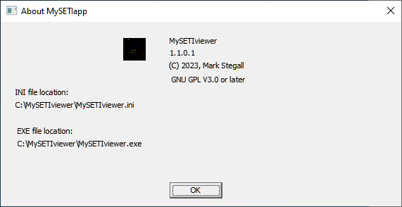

This displays the application’s current version and application information.

**Image window**

The Image window displays the overlayed image along with any ruler grids. This window size can be changed. It can be changed to just show part or all of the overlayed image.

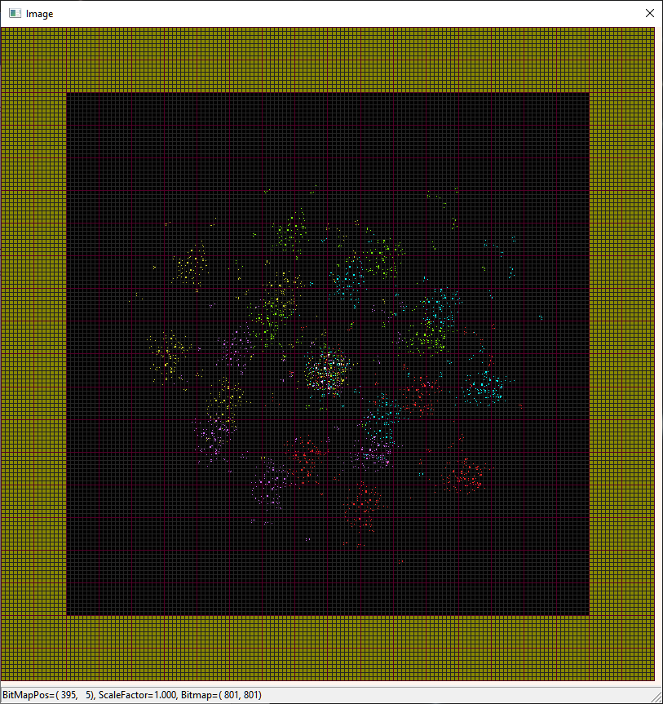

**Zooming the image**

If you mouse cursor is on the Image windows using the mouse wheel will increase or decrease the zoom of the image depending on the direction you move the wheel. Zoom scale ranges from 0.5x to 20x.

**Panning the image**

The mouse will pan the image when the cursor is initially on the Image window and the left mouse button is held down while the mouse is moved.

**Reset of the zoom and pan**

This is done in the Displays dialog.

**Status Bar**

This can be turned on or off in the Global Settings dialog.

**Version information**

V1.0.0 Dec. 19,2023 Initial release

V1.0.1 Dec. 20,2023 Fixed saving PNG file when a BMP file is saved.

V1.0.2 Dec. 20,2023 Added direction flag for y position movement of a layer

V1.1.0 Dec. 21,2023 Change, the Layers dialog changed so that it can remain open while accessing the menus.

Change, Menus, Layer heading changed to File heading

Change, Menus, New, Add Layer, Remove Layer, Reload all layers moved into the Layers dialog

Added, Global to allow the Display and Layers dialogs to stay open when pressing OK or Cancel

V1.1.1 Dec 27,2023 Added, Status bar to image window

Changed, zoom ,pan behavior of the image window

Changed, window resize of the image window

Added, reset window positions upon next restart

Correction, fixed bug when min. overlay size was not square

Changed, zoom range, now 0.5x to 20x